**Subsystem Decomposition**

Subsystems are collection of classes, associations, operations, events and constraints that are closely interrelated with each other. The objects and classes from the object model are the  
“seeds” for the subsystems. In UML subsystems are modeled as packages. This system comprises of twelve (12) major sub system.

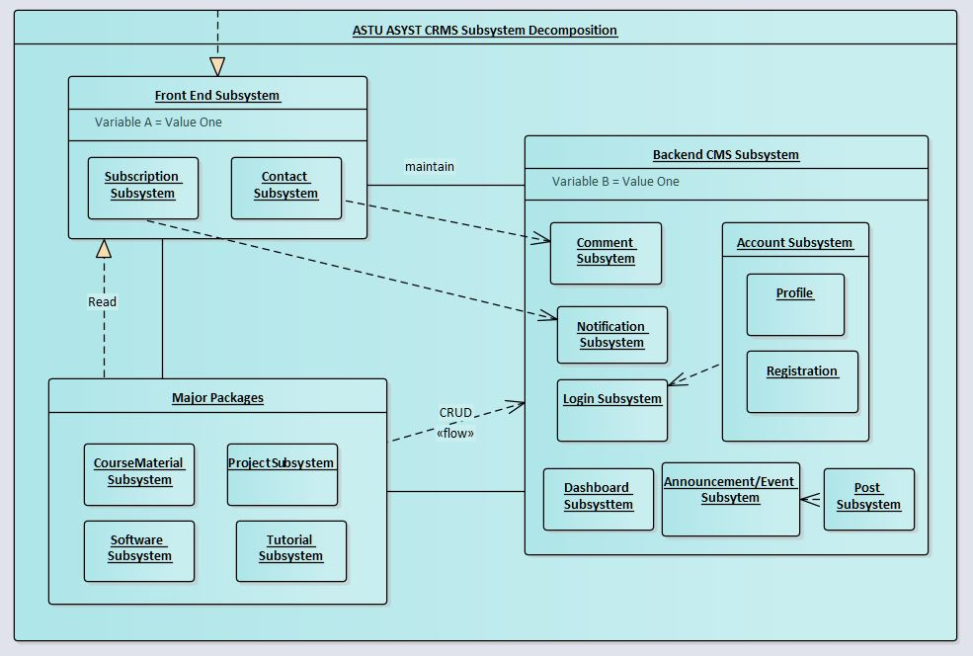

*Figure Subsystem Decomposition (Environment-Component Format)*

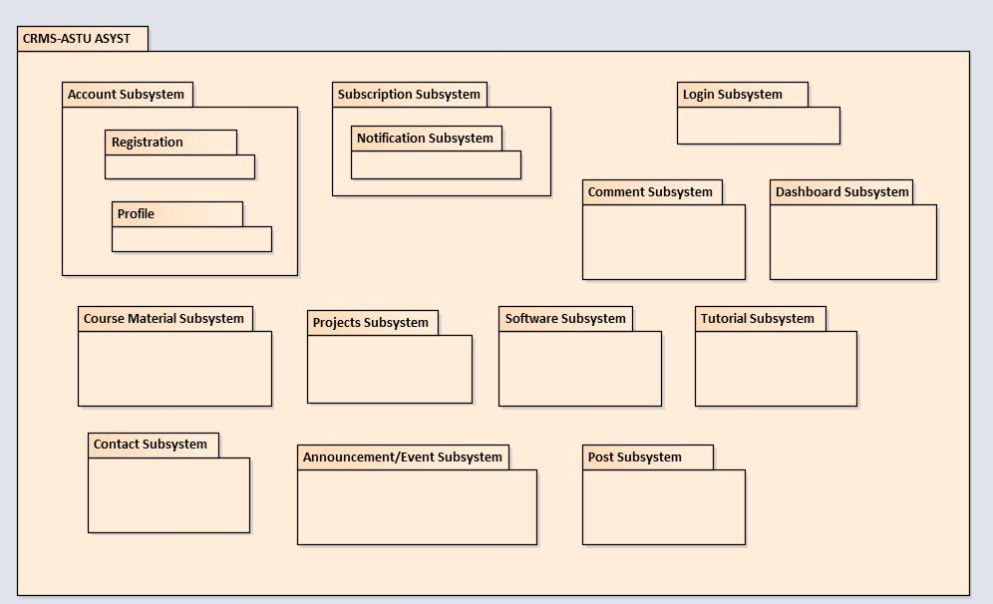

*Figure Subsystem Decomposition (Package Format)*

**4.3.3 Hardware Software Mapping**

The system will rely on both hardware and software capabilities to perform efficiently; the computer can access the website through the internet so the computer should be equipped with network adapter, network drivers, web browsers and flash player. The webserver should run on a certain engine software like nginx or ngrok with Apache Database Client running PHP Maria DB or any other Database Client.

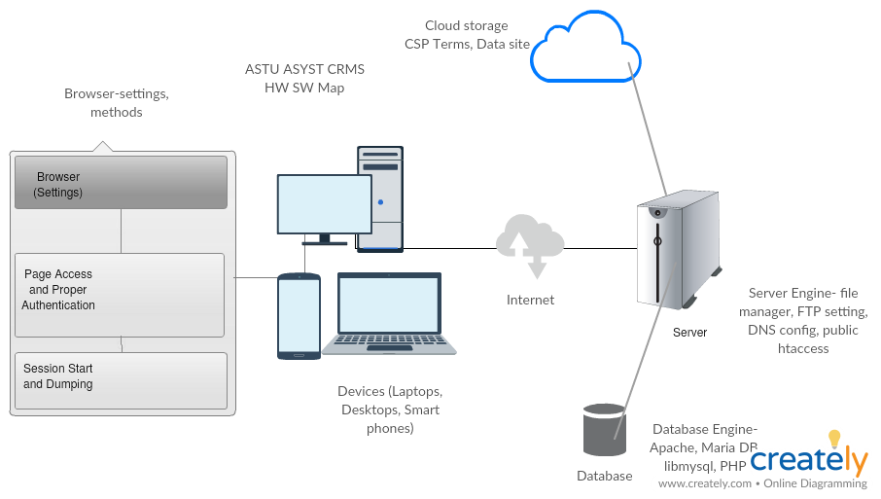

*Figure Hardware Software mapping*

**4.3.4 Persistent Data Management**

This section provides a mapping of the class diagram’s classes and objects that were identified in the requirement analysis phase into a relational database format.

Class Diagram Classes and Objects

Relational Database Tables

Mapped into

*Figure Persistent Data Managment*

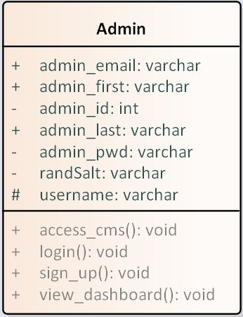

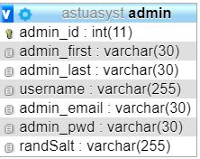

*Figure Admin object mapping*

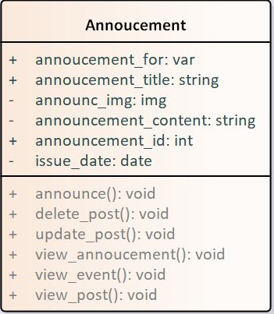

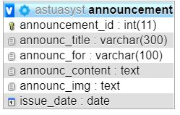

*Figure Announcement object mapping*

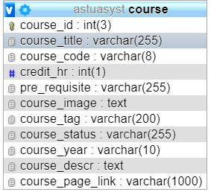

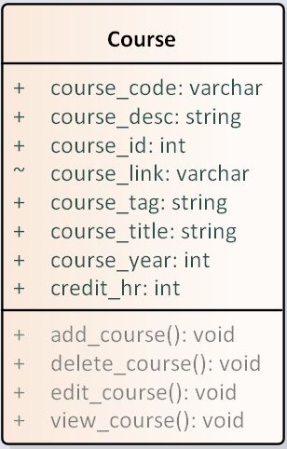

*Figure Course object mapping*

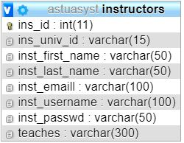

*Figure Instructor object mapping*

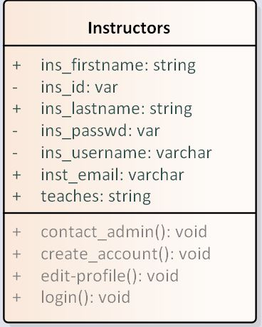

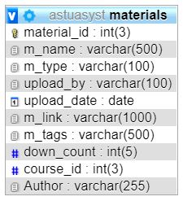

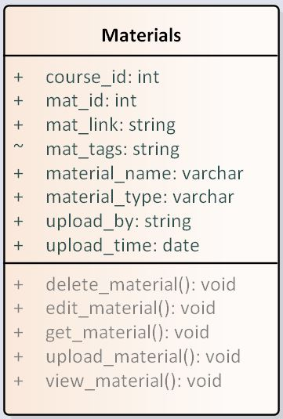

*Figure Material object mapping*

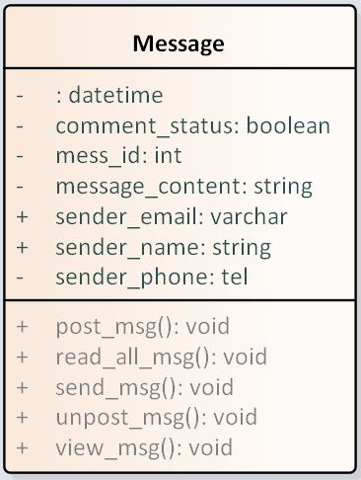

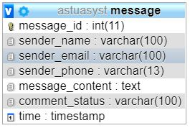

*Figure Message object mapping*

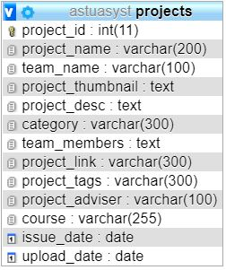

*Figure Project object mapping*

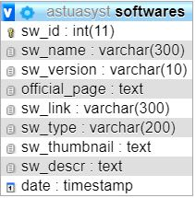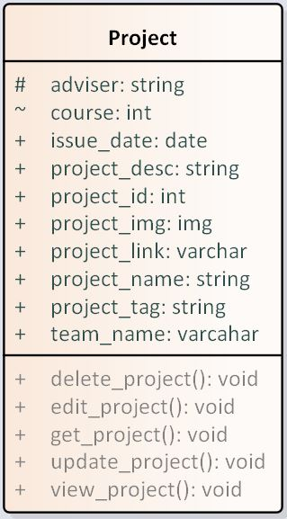

*Figure Software object mapping*

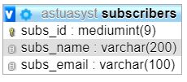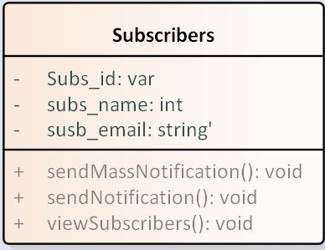

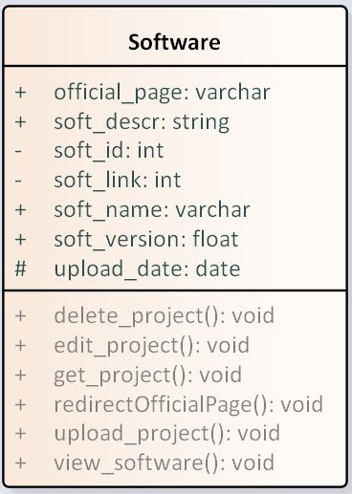

*Figure Subscribers object mapping*

**Subsystem Services**

This section describes the services each subsystem provides along with their needs and abilities.

|  |  |  |
| --- | --- | --- |
| Subsystem | Services | Class | Method |Table |
| Account Subsystem | To register instructors and set up a user account and profile for instructors which would give them access to the CMS. | User  Users Online  Instructors  Create,Update,Delete |
| LogIn Subsystem | Using the created profile, allow users to authenticate into the backend CMS. | Users  Users Online  Session |
| Course Material Subsystem | It offers the materials in an organised and interactive view in the front end and give upload option fro the CMS. | Materials  Users  Instructors  Create,Read,Update,Delete |
| Projects Subsystem | Holds the project resources with download option and allow authenticated users to upload from the CMS. | Project  Users  Instructors  Create,Read,Update,Delete |
| Software Subsystem | Holds the software resources with download & Official page option and allow authenticated users to upload from the CMS. | Software  Users  Instructors  Create,Read,Update,Delete |
| Tutorial Subsystem | Offers the tutoial resources-videos, files, books, classroom option and allow admins to upload from the CMS. | Tutorial  Users  Admins  Create,Read,Update,Delete |
| Subscription Subsystem | Students can subscribe for a newsletter and they can be notified when new material is uploaded to the website. | Subscribers  Admins  Notify |
| Contact Subsystem | Website users can leave a comment, give feedbacka and ask questions from the contact page and admins can view this messages and respond accordingly. | Message  Send()  Post() |
| Announcement/Event Subsystem | Administrators can post announcements and post events to the website. | Announcement  Event  Create,Read,Update,Delete |
| Post Subsystem | Admins can post news, current issues and recommendations to the homepage of the website if possible daily to boost interactivity. | Posts  Admins  Users  Create,Read,Update,Delete |
| Comment Subsystem | Admins can select out the messages and comments received and post them to a feedback section on the website. | Comments  Admins  Users  Create,Read,Update,Delete |
| Dashboard Subsystem | The CMS would provide a general status of aspects included in the website with graphical and tabular format. | Dashbaord  Admins  Instructors  View() |